**46th Cilcain Mountain Race**

**27th August 2018**

The unusually dry summer led to a browner than normal mountain for the 46th running of the CMR but as ever it gave good sport to the Bank Holiday Monday crowd. Leaden Skies and a cool breeze made for good running conditions, though the ground was still a little firm even after the 12 hour downpour on my setup day.

The runners gave a great reception to the 4 time champion & original course record holder, John Messum who took charge of the starter horn for this year’s race and was also on hand to award the trophies on the showground afterwards. Many thanks to John for giving his time up for the day.

First up and down the mountain was Gareth Wyn Hughes who had a great tussle with and just held off last year’s winner Phillip Robertson. Jez Brown finished forth on the line to win the Vet class and subsequently was promoted to 3rd place after time penalties were added for the first 3 runners who descended early off the north spur. They followed the U16 ascent markers off the mini-col on the ridge (my fault for using same colour markers...). I decided a time penalty was deemed a fair solution as any time gain was small due to the rougher ground lower down and it being partially a marking error on my part. Thankfully once the hoard arrived with a few regulars no one else took this alternate route.

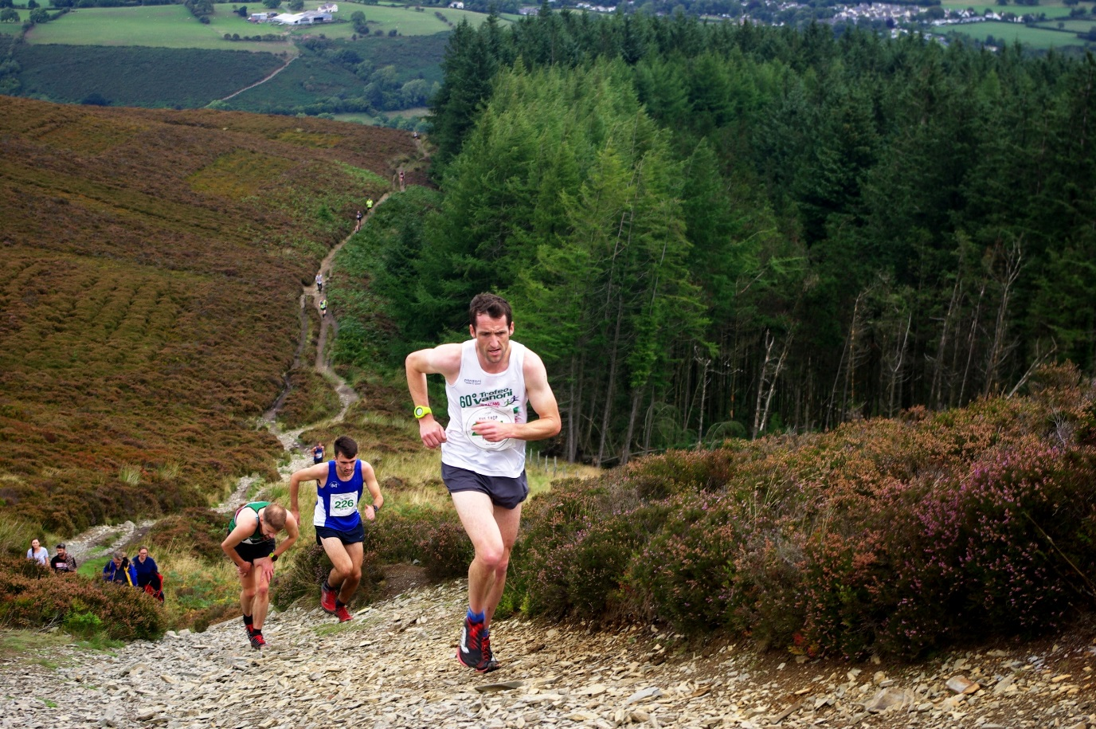

Gareth Wyn Hughes, Liam Burthem & Phillip Robertson approach the top

The Browner (local gent) and Dennis Kemp (local vet) Trophies were retained by Steve Brady. Gareth Williams took home the Llys Fynydd Shield (supervet) for the first and I am sure not the last time. A delighted Iain Wood, Chester Tri (43:00) took home the O60 class and Buckley stalwart John (Running Machine) Morris won the O70 category (They say form is temporary, class is permanent but in John’s case they seem both permanent!).

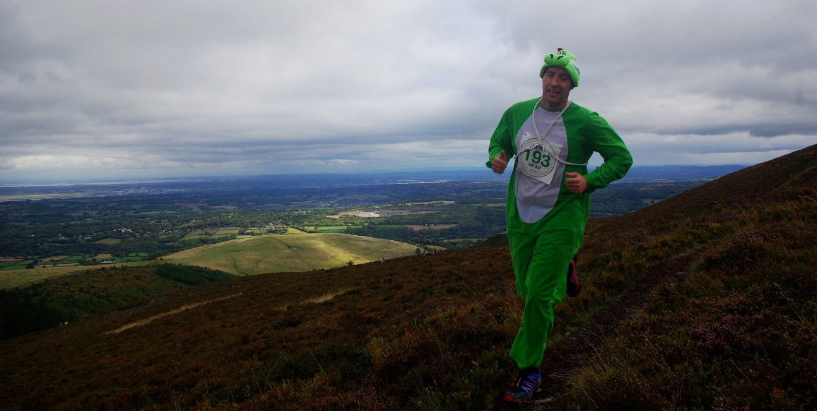

David Lyth (Buckley) won best gents fancy dress – how do you run in that....?

The ladies race was won by Sarah Ridgeway (Anderson Trophy). 2nd place went to Ursula Moore and 3rd place was “Spidergirl” Hayley Evans (WI Trophy for first local lady & best ladies fancy dress prize). Susan Fourie won the vet class (Deeside College Trophy - which is still missing….If anyone fancies sponsoring a trophy or remaking one??). Karon Forster, Spectrum Striders, won the O50 class.

Bo Hughes M18 took home the restyled Julie Tullis Trophy and Lois Lee W18 retained the Hawitt Cup.

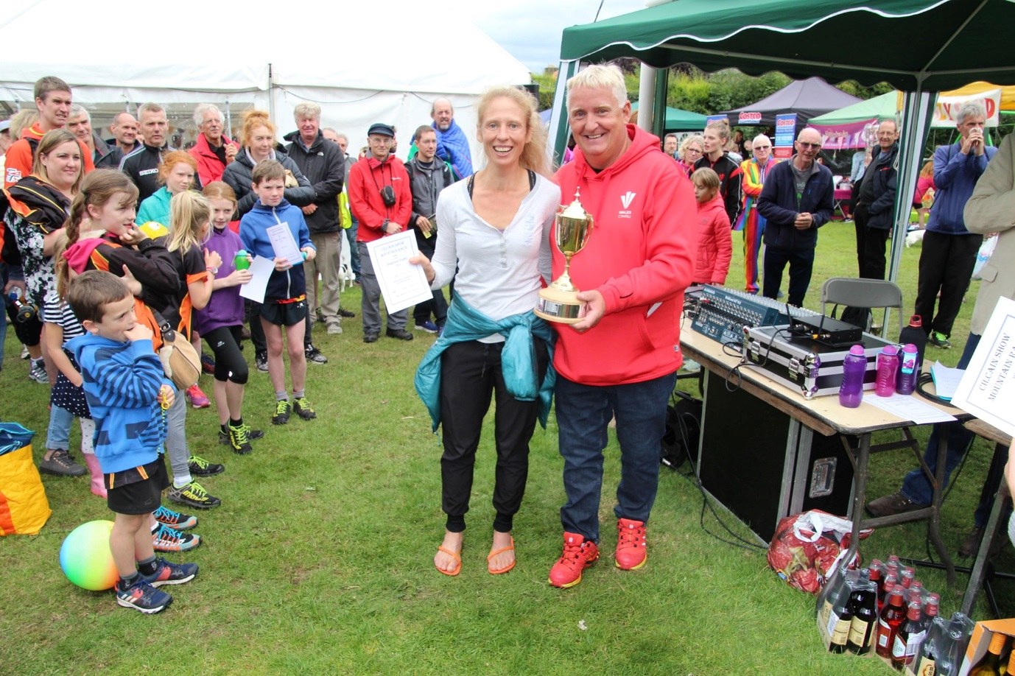

Sarah Ridgeway being presented the Anderson Trophy (first lady) by 4 time winner & record holder John Messum

The junior races had a decent turnout of 60 runners across all categories – but we still need more U16 runners folks – the trophies on offer have a good history behind them – back to 1988 for the Crittal Cup. This year’s winner of the cup was Luke Hampshire (Wallasey) (27.57) even after a detour (caused by a half asleep marshal....). Luke shared the extra distance with the winner of the W16 Snodgrass Cup Sioned Cordiner (Wrexham AC) (27.54). It was good to see a sizeable gaggle come up from the clubs such as Deeside, WESPA, Halton & Frodsham, Wirral AC. Apologies to the few who found themselves running further than they needed – learning points for marshals and signage for myself.

Winners of the other junior categories (and main race) can be found on the website [www.clwydianfellrace.org](http://www.clwydianfellrace.org)

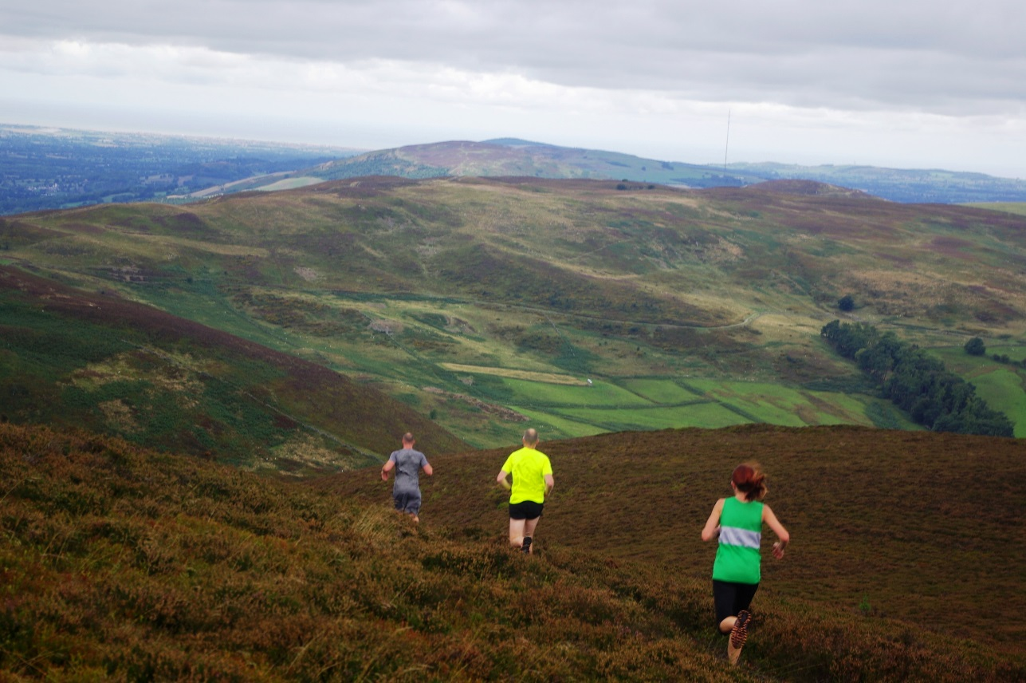

Runners descend through sun scorched heather (usually a sea of pink & purple)

The over-riding memory of the day for me will be the loving family bonds shown across all the races. The London Hughes' now annual pilgrimage north to run the event (I think Dad needs to run next year!). The affection between granddaughter and grandmother (or nain as they call them round these parts) Nora Yvonne Jones. After winning the W16 class Sioned then ran alongside Nora who that the ripe old age of (shhhh over) 70 became the first O70 female to complete the main race (ever), winning not only the O70 but also O60 class in the process. More than winning ☺

The usual (and very gracious) thanks to marshals, time keepers, hangers-on helpers. It isn't possible without you.

159 runners. I counted them all out and I counted them all back.

This is Radio Cilcain signing off (well until October and the soup run!)

hop

**Gents Overall**

|  |  |  |  |  |
| --- | --- | --- | --- | --- |
| 1 | **Gareth Wyn Hughes** | 00:32:42 | U40 | Mercia FR |
| 2 | **Philip Robertson** | 00:32:48 | U40 | Sale Harriers |
| 3 | **Jez Brown** | 00:33:41 | O40 | Buckley Runners |
| 4 | **Liam Burthem** | 00:34:05 | U40 | Liverpool Harriers AC |
| 5 | **Nathan Williams** | 00:35:22 | U40 | Vale Royal AC |
| 6 | **Scott Nixon** | 00:35:39 | U40 | Dee Striders |
| 7 | **Stuart Fludger** | 00:35:47 | O40 | N |
| 8 | **John Heap** | 00:36:43 | O40 | Wirral AC |
| 9 | **David Appleton** | 00:36:57 | U40 | N |
| 10 | **Gareth Williams** | 00:37:02 | O50 | Vale Royal AC |

**Ladies Overall**

|  |  |  |  |  |
| --- | --- | --- | --- | --- |
| 1 | **Sarah Ridgeway** | 00:39:00 | U40 | Run Snowdon |
| 2 | **Ursula Moore** | 00:40:37 | U40 | Pensby Runners |
| 3 | **Hayley Evans (FD)** | 00:41:35 | U40 | Buckley Runners |
| 4 | **Susan Fourie** | 00:43:00 | O40 | Chester Tri |
| 5 | **Carolyn Stamper-Clark** | 00:43:00 | O40 | N |
| 6 | **Bailey Ewel** | 00:43:00 | U40 | Penny Lane Striders |
| 7 | **Tammy Lewis-Jones** | 00:43:54 | O40 | Eryri |
| 8 | **Rebecca Massey** | 00:44:54 | O40 | Dee Striders |
| 9 | **Lois Lee** | 00:45:12 | U18 | Prestatyn |
| 10 | **Jane Ashbrook** | 00:45:21 | O40 | Helsby |

**Gents**

U40/MSEN Gareth Wyn Hughes Mercia 32.42

M18 Bo Hughes n/a 45.23

O40/M40 Jez Brown Buckley 33.41

O50/M50 Gareth Williams Vale Royal AC 37.02

O60/M60 Iain Wood Chester Tri 43.00

O70/M70 John Morris Buckley 49.23

**Ladies**

U40/WSEN Sarah Ridgeway Run Snowdon 39.00

W18 Lois Lee Prestatyn 45.12

O40/W40 Susan Fourie Chester Tri 43.00

O50/W50 Karon Forster Spectrum 45.24

O60&O70 Nora Yvonne Jones n/a 1:41.15