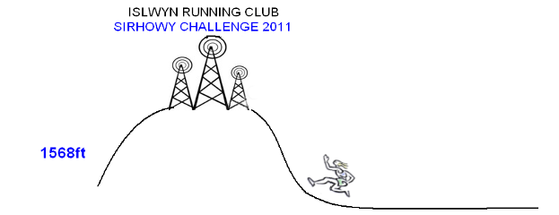
10 miles/1568feet
Sunday 15th May 10am Sponsored by Dans Bangers, Tir-y-Berth

A 10 mile scenic & challenging multi terrain route starting on the Sirhowy walk.
See Garmin course profile.

Race HQ is the Ynysddu Hotel, Ynysddu. NP11 7JW
Memento for all finishers.
Minimum Age: 16
Age categories & Male & Female team prizes (4 finishers to qualify).

Entry: £10.00 on the day or in advance by sending entry form & cheque payable to Islwyn Running Club to:
Organiser: Mike Heare
Islwyn Running Club
5 Farm Road, Swffryd, Crumlin NP11 5HX

Any queries contact: Mike Heare: 01495 245430 nikeair@farmrd.fsnet.co.uk
www.islwynrunningclub.org.uk


