Llantysilio Mountain Race 24th March

This race traverses about 3km of the Llantysilio Mountain ridge, which being largely above 475m, is a very exposed place to be in bad weather. So it was with some relief that this race took place on a just a cool and overcast day, a big plus considering the weather a week earlier.

Over the past 5 years’ races, the 2018 winner has recorded 3 third places and 1 fourth. So it was well overdue that Jez Brown of Buckley Runners was the clear winner (and V40) in 56’56” over second place Lawrence Eccles of Penny Lane Striders. The women’s race was a much closer affair with Ursula Moore of Pensby Runners beating Val Swingler (FV50 winner) of Shropshire Shufflers by only 6 seconds in 1hr 11’ 58”

Other category winners were, for the men, V50; Neil Ashcroft of Ambleside, V60; Steve Jones of Eryri and V70; John Morris of Buckley. For the women, Laura Baynham Hughes (Helsby) claimed the V40 and Menai Baugh (Denbigh) won the V60 category.

We had a total of 75 runners. Thanks to all the marshals ensuring the race went smoothly and also for the hospitality of the Sun Inn in Rhewl.

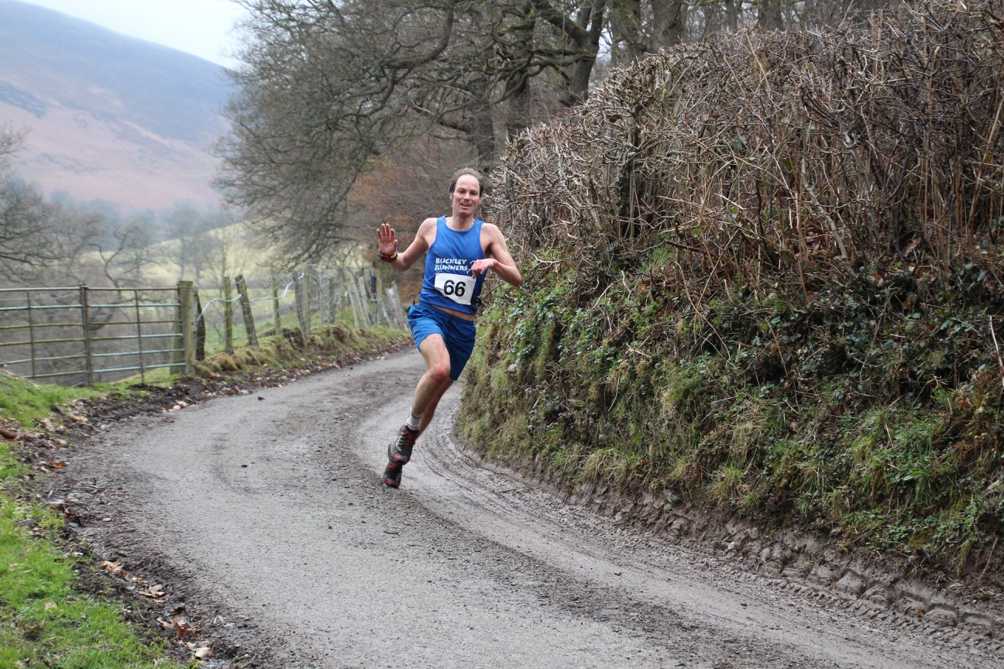

Jez Brown closes in on a win at Llantysilio

(Courtesy of *SJ Photography*)

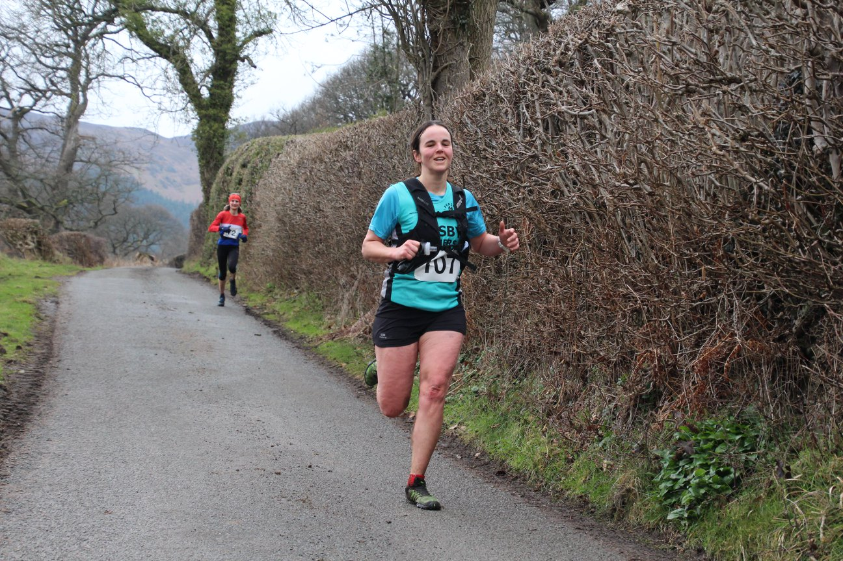

Ursula Moore wins ahead of Val Swingler

(Courtesy of *SJ Photography*)