**Clwydian Hills Fell Race 2018**

21st October 2018

**Race Report – 103 runners, 1 DNF**

“I’m sure he’s already passed me twice….”

A little bit of rain a few days before helped soften up the hills a little but yet again the weather gods smiled on the race with the rain holding off until I got to the pub after cleaning up.

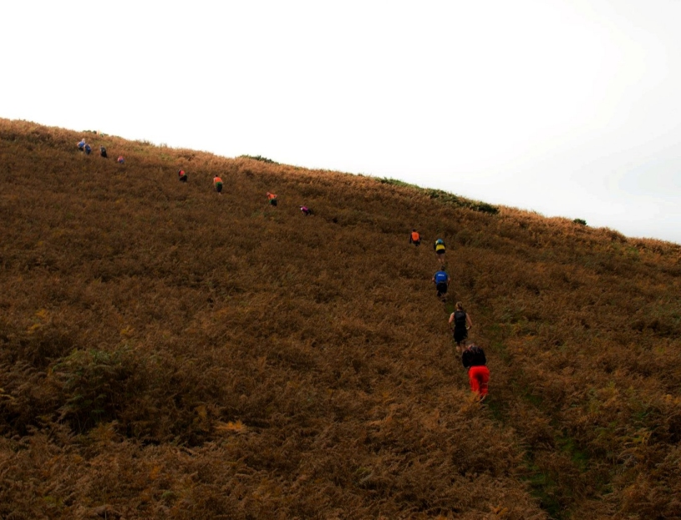 Slog up from CP4

My pre-race advice of “Remember the person in front may not be going the correct way” was ignored by the front runners and hence the race lead was dominated by navigation errors (even from the locals who should know better…) This led to some interesting chatter amongst the trailing bunch who kept seeing the leaders pass them….several times. These errors did mean a great finish though as we had 6 runners come over the 2nd last summit of Moel Dwywll together. Rob Grantham’s (1st, 1st M40, Pensby) fearless descending earned him a small lead which he kept until the finish just holding off Jez Brown (2nd, Buckley) and Gavin Roberts (3rd, 1st M23-40, Eryri). The top 3 finished within 30 seconds and the top 6 finished well within 2 minutes of each other making this one of the closest finishes ever for the race.

A delighted Simon “I never win anything” Ellis of Chester Tri took the M50 honours, Leigh Warburton (Bowland) won the M60 category and our race’s creator John “Elbows” Morris (Buckley) took the M70 class. U23 winner was David Appleton (9th).

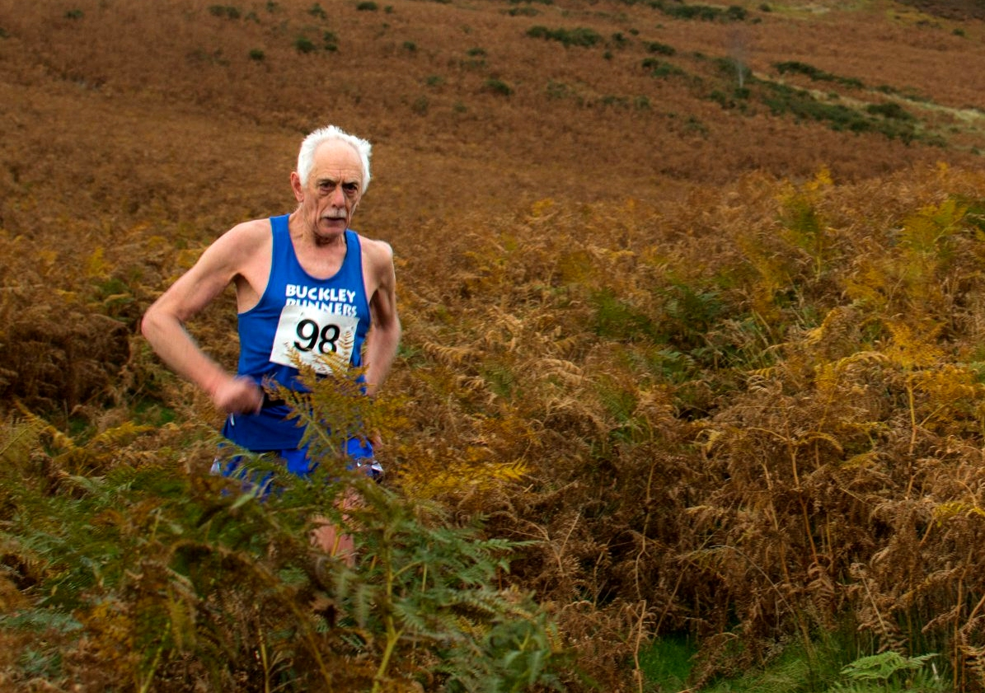

Elbows Out - no one gets past John Morris!

The ladies race was a good battle by local Hayley Evans (18th, 1st F23-40, Buckley) and Helen Brown (19th, 1st F40) finishing 20 seconds back with Alice Swift (Chorlton) finishing a couple of minutes behind them. Sally Gilliver took the W50 category.

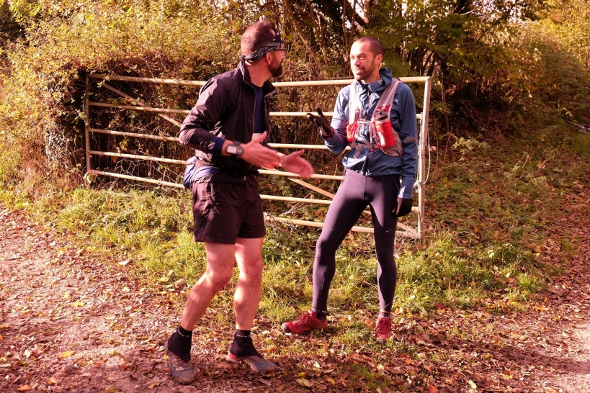

Loving your robot moves

Buckley Runners took home the Petzl Team Trophy for the first time with 636 points. Pensby finished closely with 595 points and Bowland with a brilliant 544 points. It was really great to see folks coming from further afield and in good numbers.

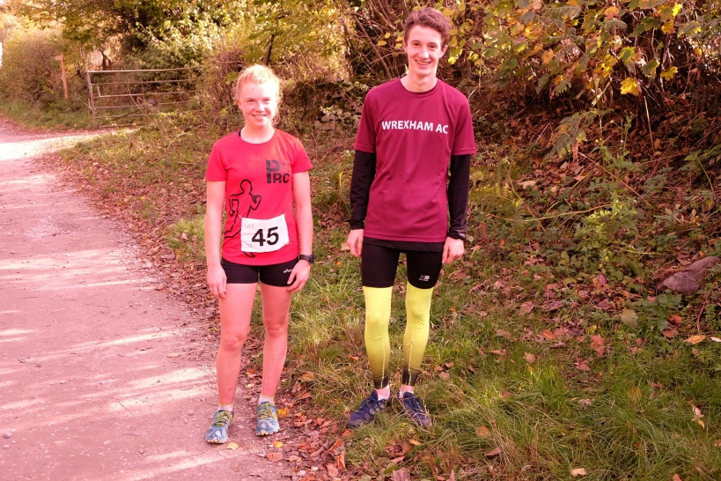

We few, we happy few…. Lois Lee (Prestatyn RC) 1st F18 & Kai Walsh (Wrexham) 1st M16

The junior races offered a great run out for Lois Lee (1st F18, Prestatyn RC) & Kai Walsh (1st M16, Wrexham AC) and meant they got all the great prizes, shiny trophies & cake for themselves. XC races in the local area the day before maybe did not help numbers but it is a shame as the courses offer a great challenge and running freedom for the youngsters who you would think would prefer it to running round a school field…? I will keep offering them… well until no one shows up maybe.

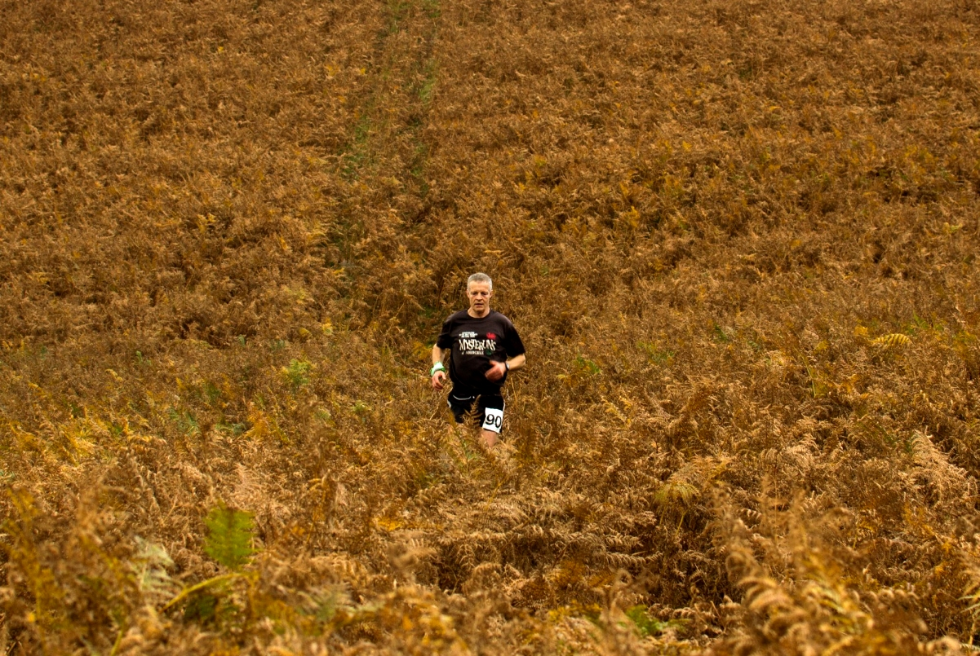

Richard Borne – Abergele Mysteruns

Refreshments, presentations and the obligatory post-race debrief chats were held in village hall. Special thanks to [NEWSAR](http://newsar.org.uk) members and the supporters group for marshalling the race & looking after the runners with homemade soup & cakes.